|  |
| --- |
| Logbook for ISD |
| Zarrar Masud - 21103253 |
|  |
|  |
|  |

Logbook for ISD

Zarrar Masud - 21103253

Contents

Introduction 2

Week 1 3

Exercises 1 3

Exercises 2 3

Exercises … 3

Week 2 4

Exercises 1 4

Exercises 2 4

Exercises … 4

Week 3 5

Exercises 1 5

Exercises 2 5

Exercises … 5

Week…13 6

Exercises 1 6

Exercises 2 6

Exercises … 6

# Introduction

½ Page

Brief intro on what was done in the module, how was experience with exercises and overall module?

**Week 1**

**Question 1**: What is a code repository (often also called version control system) used for?

Answer - Version Control System is a program used to keep version of every single data. A code repository has the same function, but also allows you to collaborate with others.

*Reference* - <https://git-scm.com/book/en/v2/Getting-Started-About-Version-Control>

**Question 2**: Why is it advantageous to use a code repository?

Answer - A graphic designer would like to keep every single version of their images as they may need to revert back to previous versions

*Reference* –

**Question 3:** Describe the different “layers” of Software that exist on a typical computer and explain why there are different layers of software.

Answer - The different layers of software are processes which take place, when instructing the computer to do a task eg. When wanting to print out a document, the request doesn’t get sent straight to the printer, it goes through processes User > Application > Operating System > Device Driver > BIOS > Hardware

Some examples of Application Software Type:

Word Processing Software > MS Word, Wordpad, Notepad.

Presentation Software > Microsoft PowerPoint

*Reference* - <http://bucarotechelp.com/computers/anatomy/96102501.asp?x=70&y=3&page=1>

**Question 4:** Describe what an algorithm is and explain why it is a useful “tool” to translate from a human level problem (we can think of) to a computer program.

Answer - An algorithm is a guideline on how to do a certain task eg. Getting up in the morning and going out, you wouldn’t put your jumper on before your shirt.

*Reference* - <https://www.bbc.com/bitesize/articles/z3whpv4>

*Reference* - <https://www.educba.com/what-is-application-software-its-types/>

**Week 2**

For Week 2, we had 4 tasks to do:

1) Write an algorithm that describes how to make scrambled eggs, try to use control words, like IF, WHEN, UNTIL, WHILE, WAIT, AND, OR.

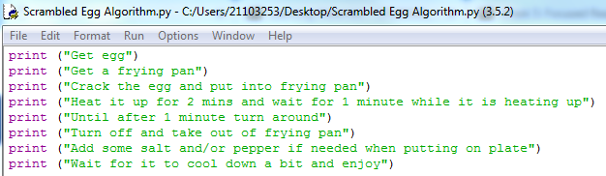

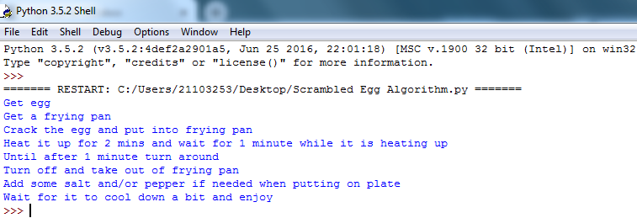

2) Is Idle (the Python language shell) an Interpreter or an Compiler or both? Explain your answer.

3) Write a command in the Idle shell that says “Hello world”

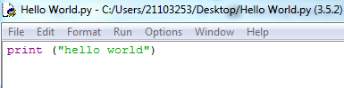

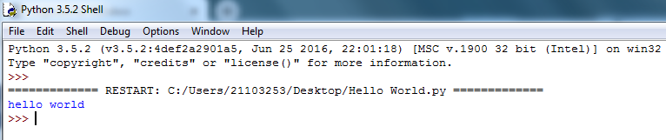

4) Write a program that produces the following output:

Hello World.

I am in my ISD class right now

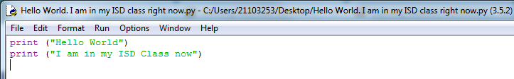

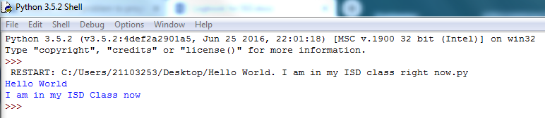

5) Write a program that asks the user for his/her name and produces an output like:

Hi there, what is your name?

>User input to be read<

Hello

“User name”

How are you?

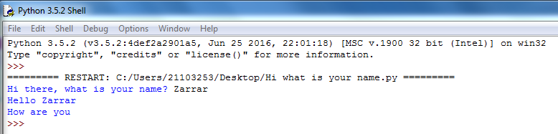

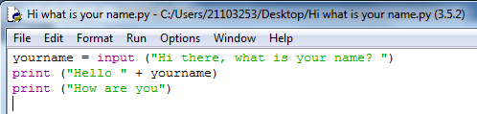

**Week 3**

For Week 3, we had 4 tasks to do:

1) Write a program that asks for two numbers (Python has all the basic mathematical functions in place, like +,-etc.), adds them up and displays the result.

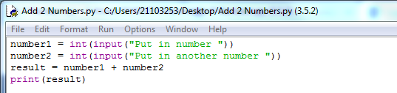

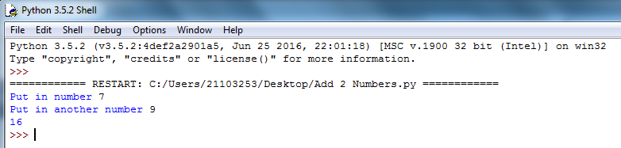

2) Answer the questions by implementing the code and run it.

a) What will the output be from the following code?

num = 4num*=2num1=num+2num1+=3print(num1) **= 13**

B) What do the following lines of code output? Why do they give a different answer?

print(2 / 3)print(2 // 3)

3) All of the variable names below can be used. But which of these is the better variable name to use?A a Area AREA area **areaOfRectangle** AreaOfRectangle

4) Which of these variables names are not allowed in Python? (More than one might be wrong.)

apple APPLE Apple2 **1Apple** **account number** account_number  **account.number**  accountNumber fred Fred return return_value **5ReturnGreatBigVariable** greatBigVariable great_big_variable **great.big.variable**

**Week 4**

For Week 4, we had 10 tasks to do:

Github:

1)If you haven’t done so yet, please sign up for Github <https://github.com/>

2) Create a repository for your source code

3)Commit (upload) your code from the previous weeks to your repositoryTasks:

1.Explain the mistake in the following code: radius = input("Radius:")x = 3.14pi = xarea = pi * radius ** 2

2.Explain the mistake in the following code :x = 4y = 5a = 3(x + y)

3.Explain the mistake in the following code: radius = input(float("Enter the radius:"))

4.Why does this code not calculate the average? print(3 + 4 + 5 / 3)

5.Consider the following code:x = 19.93y = 20.00

z = y –xprint(z)The output is 0.0700000000028 Why is that so? Improve the code so that the output is to two decimal places.

6.Find at least three compile-time errors:int x = 2Print (x, squared is, x * x)xcubed = x *** 3

7.Find two run-time errors:from math import sqrtX = 2Y = 4print(“The product of “, x, “and”, y, “is”, x + y)print(“The root of their difference is “, sqrt(x –y))

8.Write statements to prompt user for their name and ageWrite a print statement to output:Hello ____, next year you will be ____ years old!

9.Given that radius is 2 and area is calculated as 12.5678, use string format operators to print the values of the variables radius and area so that the output looks like this:Radius is: 2Area is:12.57

10.What are the values of the following expressions, assuming that p is 17 and q is 18?a.p // 10 + p % 10b.p % 2 + q % 2c.(p + q) // 2d.(p + q) / 2.0

## 

# Week…13

Continue this structure for the remaining weeks up until week 13

Some overview of the topics covered by the lecture and the exercises. Not too much, may be a paragraph.

## Exercises 1

Provide the exercises description and your answers. Where applicable use source code excerpts, explanations of these, represent your results, for example by showing screenshots of your program and, where applicable, display the use of your code repository (github) either by screenshots or by providing log data from your code repository.

## Exercises 2

Provide the exercises description and your answers. Where applicable use source code excerpts, explanations of these, represent your results, for example by showing screenshots of your program and, where applicable, display the use of your code repository (github) either by screenshots or by providing log data from your code repository.

## Exercises …

Example description of an exercise:

